Tracking Cars Using Optical Flow
This example shows how to track cars in a video by detecting motion using optical flow. The cars are segmented from the background by thresholding the motion vector magnitudes. Then, blob analysis is used to identify the cars.
Initialization
Create the System objects outside of the main video processing loop.
% Object for reading video file.
filename = 'viptraffic.avi';
hVidReader = vision.VideoFileReader(filename, 'ImageColorSpace', 'RGB',...
'VideoOutputDataType', 'single');
Optical flow object for estimating direction and speed of object motion.
hOpticalFlow = vision.OpticalFlow( ...
'OutputValue', 'Horizontal and vertical components in complex form', ...
'ReferenceFrameDelay', 3);
Create two objects for analyzing optical flow vectors.
hMean1 = vision.Mean;
hMean2 = vision.Mean('RunningMean', true);
Filter object for removing speckle noise introduced during segmentation.
hMedianFilt = vision.MedianFilter;
Morphological closing object for filling holes in blobs.
hclose = vision.MorphologicalClose('Neighborhood', strel('line',5,45));
Create a blob analysis System object to segment cars in the video.
hblob = vision.BlobAnalysis(...
'CentroidOutputPort', false, 'AreaOutputPort', true, ...
'BoundingBoxOutputPort', true, 'ExtentOutputPort', true, ...
'OutputDataType', 'double', ...
'MinimumBlobArea', 250, 'MaximumBlobArea', 3600, 'MaximumCount', 80);
Morphological erosion object for removing portions of the road and other unwanted objects.
herode = vision.MorphologicalErode('Neighborhood', strel('square',2));
Create objects for drawing the bounding boxes and motion vectors.
hshapeins1 = vision.ShapeInserter('BorderColor', 'Custom', ...
'CustomBorderColor', [0 1 0]);
hshapeins2 = vision.ShapeInserter( 'Shape','Lines', ...
'BorderColor', 'Custom', ...
'CustomBorderColor', [255 255 0]);
This object will write the number of tracked cars in the output image.
htextins = vision.TextInserter('Text', '%4d', 'Location', [1 1], ...
'Color', [1 1 1], 'FontSize', 12);
Create System objects to display the original video, motion vector video, the thresholded video and the final result.
sz = get(0,'ScreenSize');
pos = [20 sz(4)-300 200 200];
hVideo1 = vision.VideoPlayer('Name','Original Video','Position',pos);
pos(1) = pos(1)+220; % move the next viewer to the right
hVideo2 = vision.VideoPlayer('Name','Motion Vector','Position',pos);
pos(1) = pos(1)+220;
hVideo3 = vision.VideoPlayer('Name','Thresholded Video','Position',pos);
pos(1) = pos(1)+220;
hVideo4 = vision.VideoPlayer('Name','Results','Position',pos);

% Initialize variables used in plotting motion vectors.
lineRow = 22;
firstTime = true;
motionVecGain = 20;
borderOffset = 5;
decimFactorRow = 5;
decimFactorCol = 5;
Tracking Cars in Video
Create the processing loop to track the cars in video.
while ~isDone(hVidReader) % Stop when end of file is reached
frame = step(hVidReader); % Read input video frame
grayFrame = rgb2gray(frame);
ofVectors = step(hOpticalFlow, grayFrame); % Estimate optical flow

% The optical flow vectors are stored as complex numbers. Compute their
% magnitude squared which will later be used for thresholding.
y1 = ofVectors .* conj(ofVectors);
% Compute the velocity threshold from the matrix of complex velocities.
vel_th = 0.5 * step(hMean2, step(hMean1, y1));

% Threshold the image and then filter it to remove speckle noise.
segmentedObjects = step(hMedianFilt, y1 >= vel_th);

% Thin-out the parts of the road and fill holes in the blobs.
segmentedObjects = step(hclose, step(herode, segmentedObjects));

% Estimate the area and bounding box of the blobs.
[area, bbox, extent] = step(hblob, segmentedObjects);
% Select boxes inside ROI (below white line).
Idx = bbox(:,1) > lineRow;

% Based on blob sizes, filter out objects which are unlikely to be
% cars. When the extent property of a blob exceeds 0.4 (40%),
% classify it as a car.
isCar = extent > 0.4;
numCars = sum(isCar); % Number of cars
bbox(~isCar, :) = []; % Keep only the bounding boxes for objects
% classifed as cars.

% Draw bounding boxes around the tracked cars.
y2 = step(hshapeins1, frame, bbox);

% Display the number of cars tracked and a white line showing the ROI.
y2(22:23,:,:) = 1; % The white line.
y2(1:15,1:30,:) = 0; % Background for displaying count
result = step(htextins, y2, int32(numCars));

% Generate coordinates for plotting motion vectors.
if firstTime
[R C] = size(ofVectors); % Height and width in pixels
RV = borderOffset:decimFactorRow:(R-borderOffset);
CV = borderOffset:decimFactorCol:(C-borderOffset);
[Y X] = meshgrid(CV,RV);
firstTime = false;
end

% Calculate and draw the motion vectors.
tmp = ofVectors(RV,CV) .* motionVecGain;
lines = [Y(:), X(:), Y(:) + real(tmp(:)), X(:) + imag(tmp(:))];
motionVectors = step(hshapeins2, frame, lines);

% Display the results
step(hVideo1, frame); % Original video
step(hVideo2, motionVectors); % Video with motion vectors
step(hVideo3, segmentedObjects); % Thresholded video
step(hVideo4, result); % Video with bounding boxes
end

release(hVidReader);
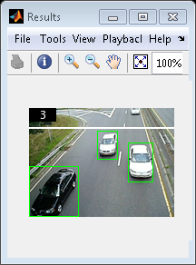
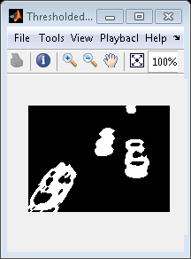
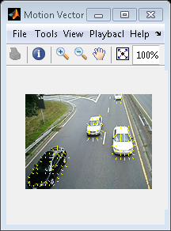
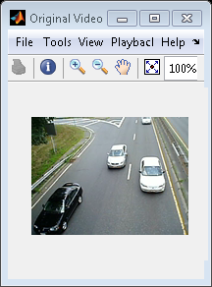
The output video shows the cars which were tracked by drawing boxes around them. The video also displays the number of tracked cars.

